Shrek | https://amzn.eu/d/iXjIRfz
Donkey | https://amzn.eu/d/4EXLxv1
Puss in Boots | https://amzn.eu/d/eoR3IOP
Farquaad | https://amzn.eu/d/6sRFm0W
Gingerbread man | https://amzn.eu/d/0aBedxY
Mirror | https://amzn.eu/d/dXHntO2
Fiona | https://amzn.eu/d/1Po0pwe
Pinocchio | https://amzn.eu/d/80zcbqx
Ugly Duckling | https://amzn.eu/d/bcEdmxG
3 Bears | https://amzn.eu/d/fiFFTUk
3 Pigs | https://amzn.eu/d/etyC6fu
People ofDuloc | Rags- Outfits based on Hard Knock life (Annie)
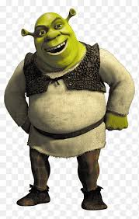
Roan St Patrick’s: Shrek
Dear parents, Please find attached the links for the costumes for the school show. These links are to Amazon, but you are more than welcome to find a cheaper alternative elsewhere if you prefer. If you have any questions, please let me know.
Thank you

Narrators | Dressed as people of Duloc
Cats | https://amzn.eu/d/hoXzh60
Guards | https://amzn.eu/d/6ZKroOs
Army | https://amzn.eu/d/9oXIgtz

