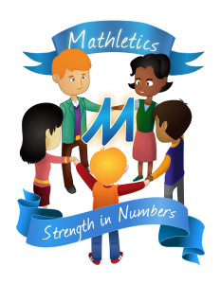
Mathletics Parent Information Booklet

Dear parent,
We are delighted to say that we will be providing the Mathletics program for all pupils again this year! The program has been fully updated for the new year! Mathletics is a captivating online learning space providing students with the tools they need to be successful learners, both in the classroom and beyond. The program successfully supports classroom learning, and provides a platform for pupils to take charge of their own learning, and extend it beyond the classroom!
Curriculum Activities
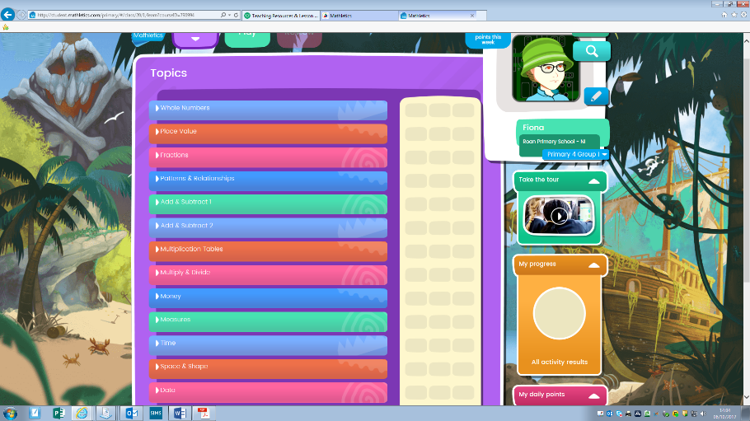
- Activities are grouped into different topics and areas of maths, covering the Northern Ireland Curriculum.
- Typically, there are 10 questions in each activity.
- The help facility is fantastic in these activiites. Pupils are guided through how to complete the questions using illustrative worked examples. Pupils can play the help facitily by clicking on the icon in the top right hand corner of the particular activity. This is really benificial for children who struggle to retain their maths knowledge, and also instructs pupils through new maths challenges.
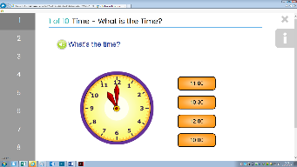
- Ten points are awarded for every correct answer. Answers can be reviewed at the end of each activity. Activities can be repeated as many times as you want.

Live Maths
Pupils can select to play live mathletics against other pupils in their class, school, around the world or they may play against the computer. Live Mathletics is great for promoting and developing pupils’ mental maths skills, and pupils really enjoy the competitive nature of this aspect of the program.
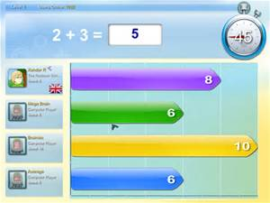

How Much Time Should My Child Spend on Mathletics Each Week?
Mathletics can be accessed throughout the year, and the school encourages at least one weekly session on Mathletics at home.
We will be starting a 3-week program in school, beginning Monday 23rd November, when we will be putting a large focus on the use of Mathletics both at home and in school. A weekly House Point will be awarded to one child per class showing excellent effort and Mrs McKeown will be selecting a wekly Mathlete of the Week.

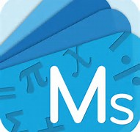
Computers &Tablets
You can access Mathletics via a computer or a tablet which is connected to the internet. There is also a handy app available for ipads and tablets!

Please have a go at accessing the website or app at home this week. Please send a note to school if your child is having difficulty accessing the program at home.
The website is www.mathletics.com

Monitoring Achievement and Homework
Teachers may set homework using the Mathletics program to support their classroom teaching. Teachers can track pupils’ progress on any of the activities attempted by your child, helping us to support and encourage them in school.
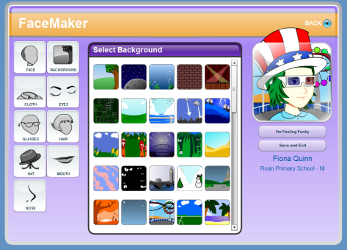
Avatar
Your child has a Mathletics Avatar (cartoon style picture) within the Mathletics website which can be customised. Every bronze certificate earns 100 credits to buy accessories or different outfits for their Avatar in the Mathlete shop.

