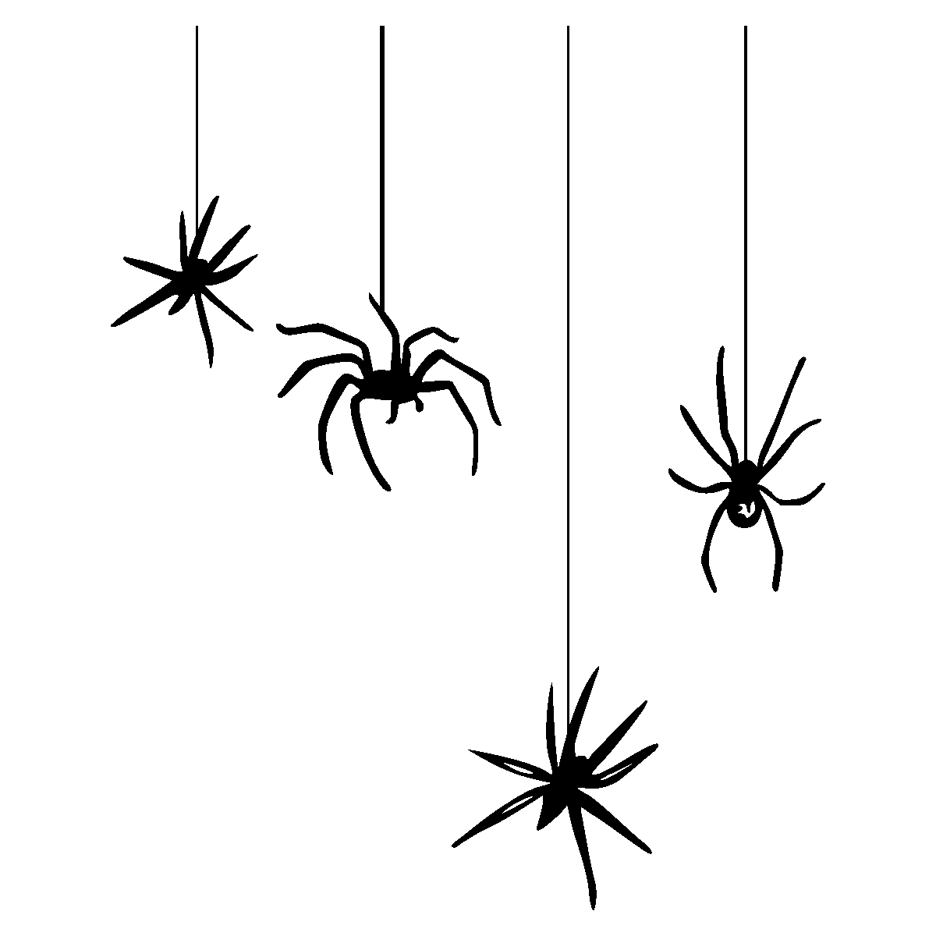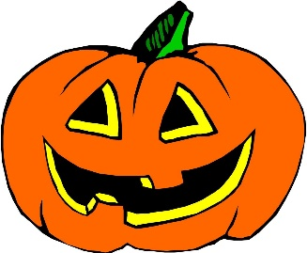 Roan St Patrick’s

Halloween Raffle

__________

Family/Seller Name: __________

|  |  |  |
| --- | --- | --- |
| Name | Contact number | Paid |
|  |  |  |
|  |  |  |
|  |  |  |
|  |  |  |
|  |  |  |
|  |  |  |
|  |  |  |
|  |  |  |
|  |  |  |
|  |  |  |
|  |  |  |
|  |  |  |
|  |  |  |
|  |  |  |
|  |  |  |
|  |  |  |
|  |  |  |
|  |  |  |
|  |  |  |

£1.00 per entry. Please return by **Friday 13th November**