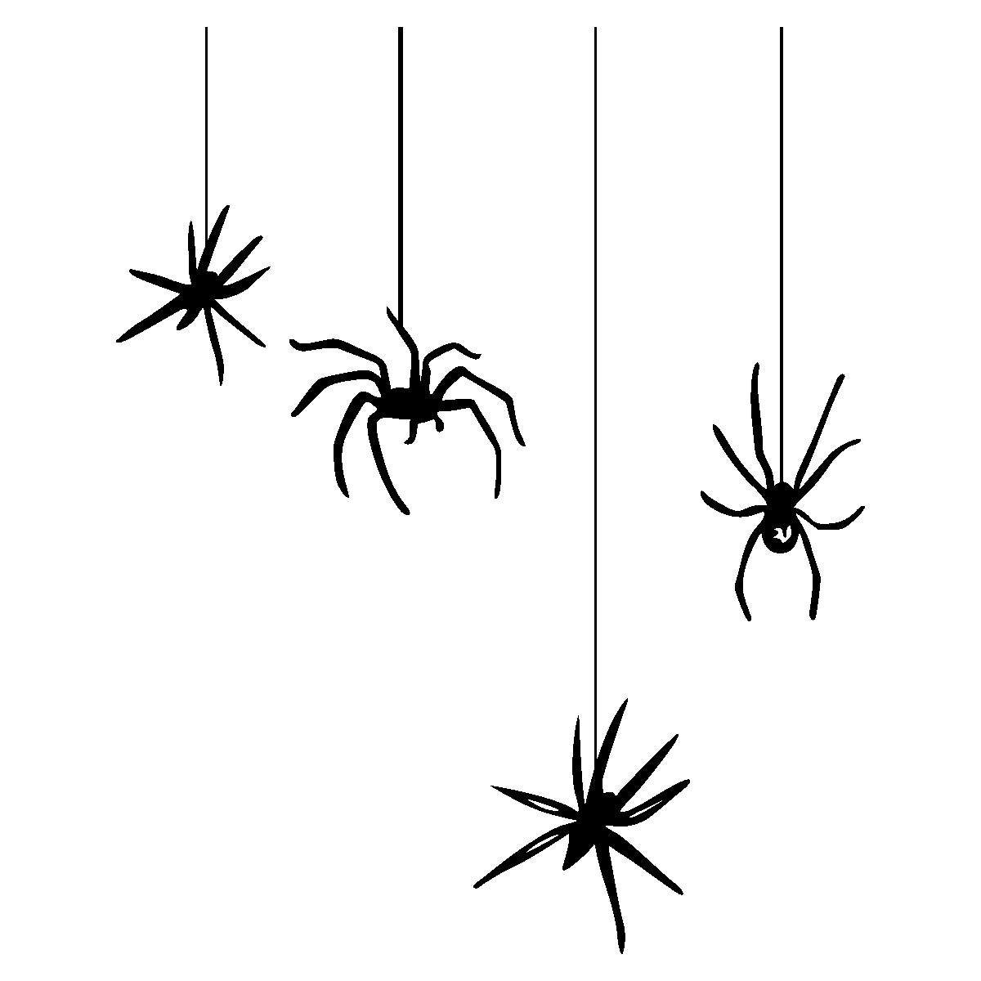


Roan St Patrick’s
Halloween Raffle

__________
Family/Seller Name: __________
Name | Contact number | Paid
£1.00 per entry. Please return by Friday 13th November

