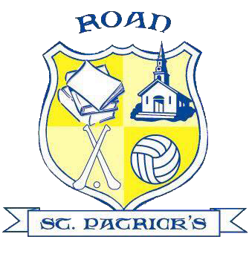
If a Child displays symptoms…

- DO NOT send them to school.

- Inform the school.

- The child and immediate household will need to arrange to be tested.

- If the test is positive follow the latest government "Stay at Home Guidance" and inform the school of the result.

- If the test is negative the child should stay at home until 48 hours after there have been no symptoms.

- If someone in the household tests positive, the child must stay at home for 14 days after the first person in the household became ill.

If a Child tests positive for Coronavirus…
- DO NOT send them to school.
- Inform school and follow latest government "Stay at Home Guidance".
- The school will follow the latest guidance from the ‘Test, Trace and Protect’ programme which may result in members of staff from the child's bubble, all pupils from the child's bubble and siblings of the child with a positive test being sent home for 14 days (siblings of other children within the bubble would be able to attend school as normal).
- All those sent home should arrange a test if showing symptoms and inform the school of the result. They will need to stay at home for 10 days from when they began to display symptoms.
- The classroom, toilet and cloakroom areas will be given a DEEP CLEAN.
- If those sent home receive a negative test result, they must still stay at home until the 14-day period is completed.
- If a positive test result is returned follow the latest government "Stay at Home Guidance".

Those in isolation will move to the school’s new online learning platform

